SET partition 1

Other trails made while trying to get the least difference. It took me 2 days to get one least difference less than 50.

Best Least Difference: 116

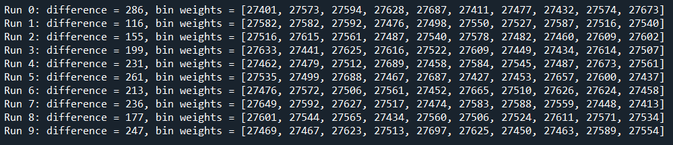

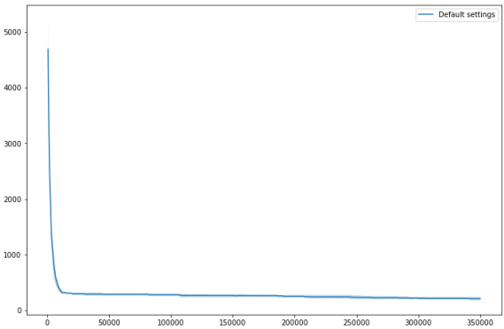

Changes made other than the given algorithm while executing:

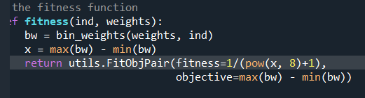

Best Least Difference: 83

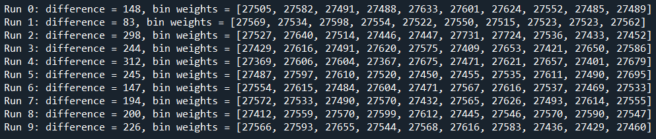

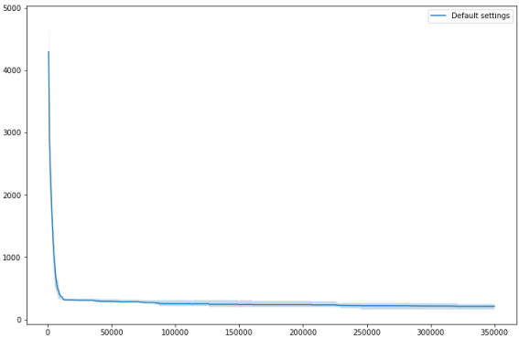

Changes made other than the given algorithm while executing:

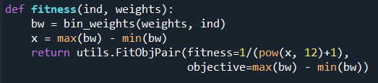

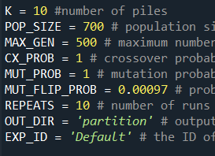

Best Least Difference: 77

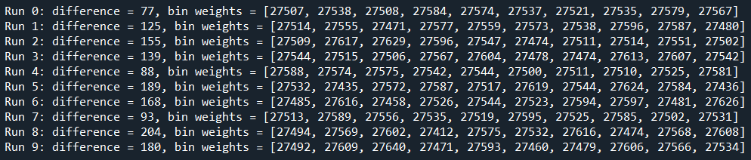

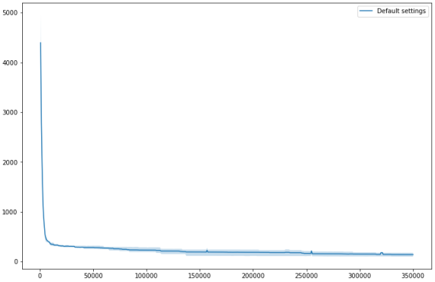

Changes made other than the given algorithm while executing:

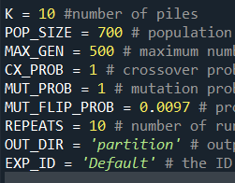

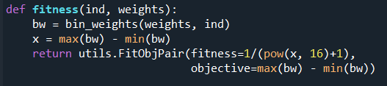

Best Least Difference: 65

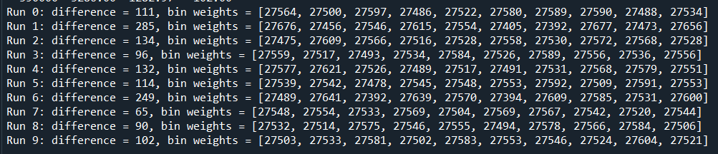

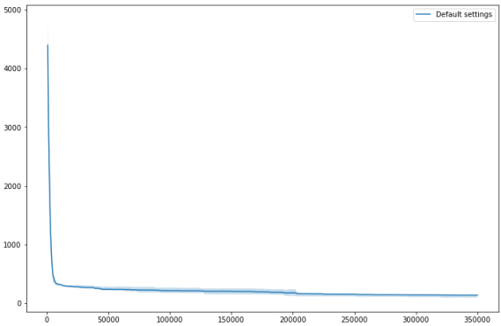

Changes made other than the given algorithm while executing:

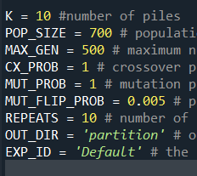



Best Least Difference: 58

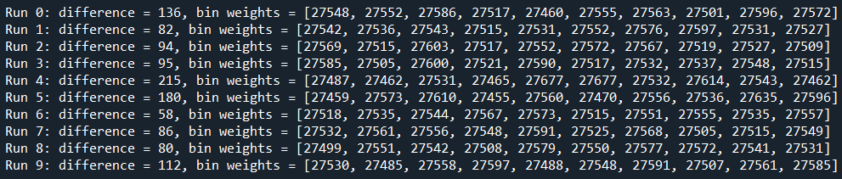

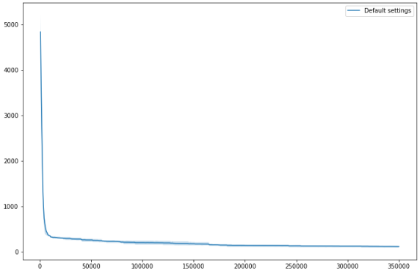

Changes made other than the given algorithm while executing:

